**Family Matters, the Annapolis County Family Resource Center**

“Building Happy, Healthy Families!” Summer 2017

What We Offer

Family Matters offers **FREE** programs and services to families in Annapolis County, with limited transportation provided.

Annual General Meeting(AGM)

Please join us for our AGM on June 26 at the centre from 12:30-2. Everyone is welcome to attend. Come to see what Family Matters has to offer and what you could offer to help Family Matters! Hope to see you there!

Summer at Family Matters

***Passport to Play***

This summer Family Matters has received funding for a Passport to Play Project. Children who sign up will be given a passport with activities to complete by August 10. Some of the activities will be completed during park days and field trips. **Sign up required.**

***Pop up in the Park***

This summer at Family Matters we are offering Pop up in the Park at various locations on Tuesdays mornings throughout the summer. Join us for water play, messy play, and nature and carnival themes. Sign up not required.

***Field Trips***

Join us for various field trip throughout the summer from Oaklawn Farm, Delaps Cove, Mickey Hill, pools in our community and much more. Family Matters covers the cost of all regular participants. Check our calendar for dates and time.



Who We Are

Family Matters is a non-profit organization in Annapolis County. Our mission is to develop, coordinate and deliver programs, services, and supports that are proven to promote the health and well being of children aged 0-18 years and their families, guardians, and caregivers in Annapolis County.

**Want to get in touch with us?**

***Miss Denise:*** [***denise@family-matters.ca***](mailto:denise@family-matters.ca)

***Miss Billie Jo:*** [***billiejo@family-matters.ca***](mailto:billiejo@family-matters.ca)

***Miss Hollie:*** [***fhdcfamilymatters@gmail.com***](mailto:fhdcfamilymatters@gmail.com)

***Miss Amanda:*** [***amanda@family-matters.ca***](mailto:amanda@family-matters.ca)

***Miss Crystal:*** [***crystal.familymatters@gmail.com***](mailto:crystal.familymatters@gmail.com)

***Miss Penny:*** [***pennyrafuse@gmail.com***](mailto:pennyrafuse@gmail.com)

***Miss Jennifer:*** [***jencfamilymatters@gmail.com***](mailto:jencfamilymatters@gmail.com)

***Miss Ayla:*** [***aylamedicraft.p.j@gmail.com***](mailto:aylamedicraft.p.j@gmail.com)

***Miss Kourtney****:* [***kourtney@family-matters.ca***](mailto:kourtney@family-matters.ca)

***Miss Roberta: roberta.familymatters@gmail.com***

***Miss Fiona: fiona.familymatters@gmail.com***

***Miss Paige: paige.familymatters@gmail.com***

***Need a drive? Contact Miss Kourtney either at Family Matters or on her work cell phone (902- 824-3162) between 8:30- 3:00 Monday to Friday***

10 Middle Road

Lawrencetown N.S.

B0S 1M0

902-584-2210

[www.family-matters.ca](http://www.family-matters.ca)

Check us out on Facebook: Family Matters, the Annapolis County Family Resource Center

Open Monday -Friday 8:30-4:00

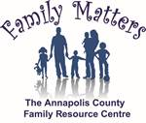

**Prenatal**

*All expecting mothers, fathers and support people are welcome to attend prenatal education classes. The following topics will be covered; pre-natal care, comfort measures, fetal development, medical interventions, stages of labor, breastfeeding, preparing for a new baby, attachment and nutritional, mental, emotional and physical health.*

**Lending Library**

**Ongoing throughout the year as needed**

*Come visit our main location or ask staff about our children’s books, toys, resources, and Breast Pump lending opportunities at Family Matters.*

Mother Hubbard’s Cupboard

**Ongoing throughout the year as needed**

*Stop by Family Matters and visit our Cupboards… pick up some new to you clothing, diapers, baby food, and other items as they are available. If you have anything in good condition that you want to donate, please feel free to talk to staff about this.*

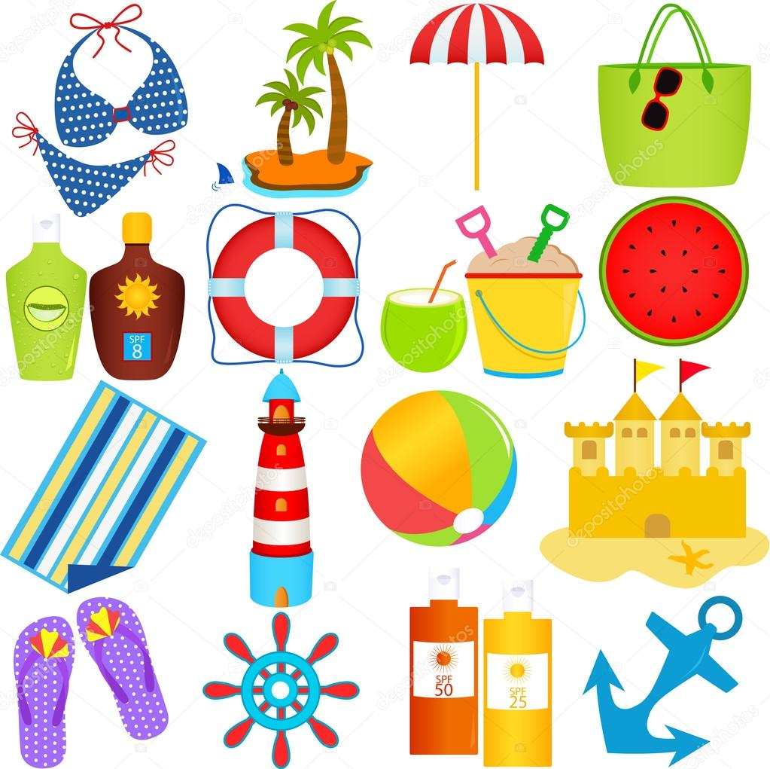

**Parenting Journey**

**Home Visits as scheduled by you and the home visitor**

*Parenting journey home visitors visit families in their homes (as requested by families) and offer support in the following areas; child/youth well being and development, parenting, family life management and community connectedness, linkages and referrals.*

**Family Home Daycare Agency**

**Various homes in Annapolis County supported by our Consultant**

*Going back to work? Need Childcare? Get in touch with Hollie (Family Home Daycare Consultant) to find an approved home to help you out. Do you love working with children? Want to stay at home with your children? Check with Hollie on how you can become an approved home.*

**Doula Services**

**Ongoing as needed throughout the year**

*Having a baby? Want support as you deliver? Contact Family Matters and talk to one of our Doula’s.*

**Drop in Play**

**At Family Matters, call ahead to make sure the playroom is available**

*Need a change of scenery? Our play room is available for you and your children to play.*

